**Level 1: PC Tower Case**

**Outline**

Learn about the internals of a standard PC case by examining physical samples and selecting and labeling images found on-line. Gain deeper knowledge by researching and reporting on specific components.

**Questions**

1. Find one (or more) images that clearly show the internals of a PC Tower Case.   
   (i.e. Google images using keywords “PC Case Internals”)
2. Clearly label the following components (using arrows) on your image of the PC case internals:
   1. Motherboard
   2. Power Supply
   3. Hard Disk Drive
   4. Optical Disk Drive (e.g.DVD)
   5. USB Expansion Ports
   6. Monitor Port
   7. Audio Ports
   8. Ethernet Port
   9. Cooling Fan  
      **Question 1 and 2**

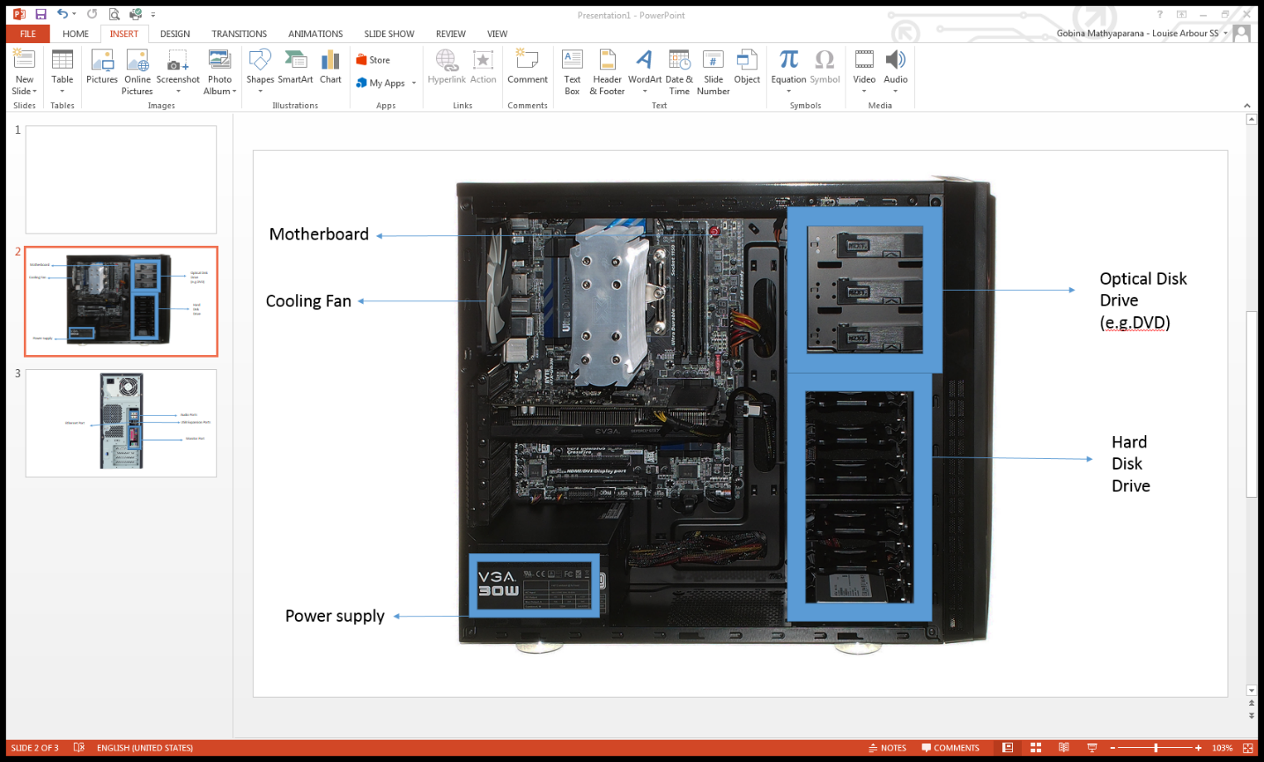

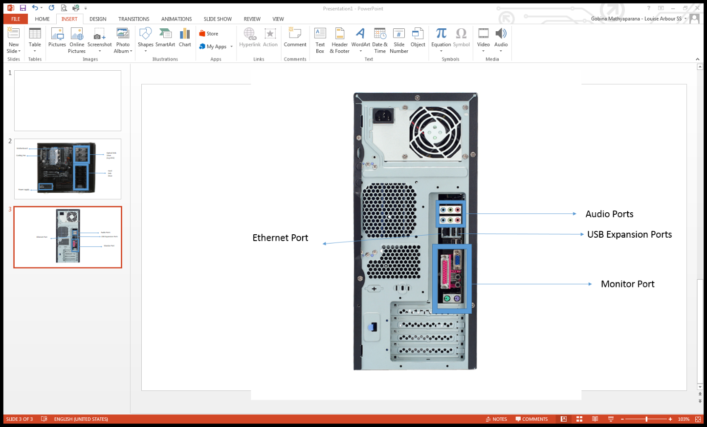

1. Research more in-depth about “Motherboards”. Make notes on the following:
   1. What different versions are currently available (speed and capacity)
   2. How the component has changed since the 1980’s
2. Research more in-depth about “Hard Disk Drives”. Make notes on the following:
   1. What different versions are currently available (speed and capacity)
   2. How the component has changed since the 1980’s

**Level 2: PC Motherboard**

**Outline**

Learn about the structure of a standard PC motherboard by examining physical samples and selecting and labeling images found on-line. Gain deeper knowledge by researching and reporting on specific components.

**Questions**

1. Find one (or more) images that clearly show the layout of a PC Motherboard.   
   (i.e. Google images using keywords “PC Motherboard”)
2. Clearly label the following components (using arrows) on your image of the PC motherboard:
   1. CPU (and fan)
   2. RAM Memory
   3. Disk Drive Interface (IDE or SATA)
   4. GPU Graphics Processor (either on-board or Graphics Card)
   5. Sound Processor (either on-board or Sound Card)
   6. Wi-Fi / Ethernet Network Interface (either on-board or Graphics Card)

1. Research more in-depth about “CPU Processor Chip”. Make notes on the following:
   1. What different versions are currently available (speed and capacity)
   2. How the component has changed since the 1980’s
2. Research more in-depth about “RAM Memory”. Make notes on the following:
   1. What different versions are currently available (speed and capacity)
   2. How the component has changed since the 1980’s

**Level 3: Peripheral Devices**

**Outline**

Learn about how peripheral devices are connected to the back side of a typical PC tower case. Examine physical samples, select and labeling images found on-line and gain deeper knowledge by researching and reporting on specific components.

**Questions**

1. Find one (or more) images that clearly show the layout of the back of a typical PC tower case.   
   (i.e. Google images using keywords “Back Of PC Tower”)
2. Clearly label the following components (using arrows) on your image of the back of a typical PC tower case:
   1. Power cord and power switch
   2. Monitor Interface (VGA or DVI or HDMI)
   3. Mouse Interface (USB or PS/2)
   4. Keyboard Interface (USB or PS/2)
   5. USB Ports
   6. Audio Inputs / Outputs
   7. Ethernet Interface

1. Research more in-depth about “Monitor Technology”. Make notes on the following:
   1. What different versions are currently available (e.g. VGA / DVI, Flat Panel Technology))
   2. How the component has changed since the 1980’s (e.g. Display Resolution, Technology)
2. Research more in-depth about “External Portable Storage”. Make notes on the following:
   1. Floppy Disks
   2. CD-ROM / DVD / Recordable CD/DVD
   3. USB Memory Drives
   4. Compact Flash Memory
   5. Cloud Based Storage